Donor-Advised Grant
Recommendation Form
333 South 132nd Street
Omaha, NE 68154
Phone: (402) 334-6551
Fax: (402) 334-6765
Email: dwalker@jewishomaha.org
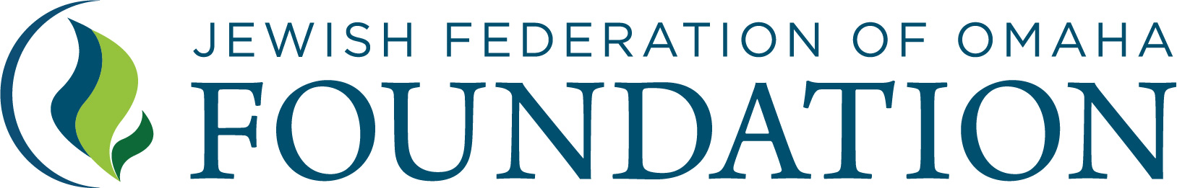

Account Information
Donor-Advised Fund Name | Account Number (if known)

Grant recommendation: Pursuant to the terms of the Donor-Advised Fund which I have established at the Jewish Federation of Omaha Foundation, I hereby suggest that you pay the following amounts to the following organizations:

1.  Organization Name  Organization’s Address  City State Zip Code | $  Grant Amount ($100 minimum)  Notes regarding donation (if any):
2.  Organization Name  Organization’s Address  City State Zip Code | $  Grant Amount ($100 minimum)  Notes regarding donation (if any):
3.  Organization Name  Organization’s Address  City State Zip Code | $  Grant Amount ($100 minimum)  Notes regarding donation (if any):
Signature: The above suggested distribution does not represent the payment of any pledge or other financial obligation.
If any benefits or privileges are offered in connection with such distribution(s), I have not accepted and will not accept them.

___________________________________________________ ___________________________________
Signature Date

